https://github.com/EvanBrown-Git/Essentials
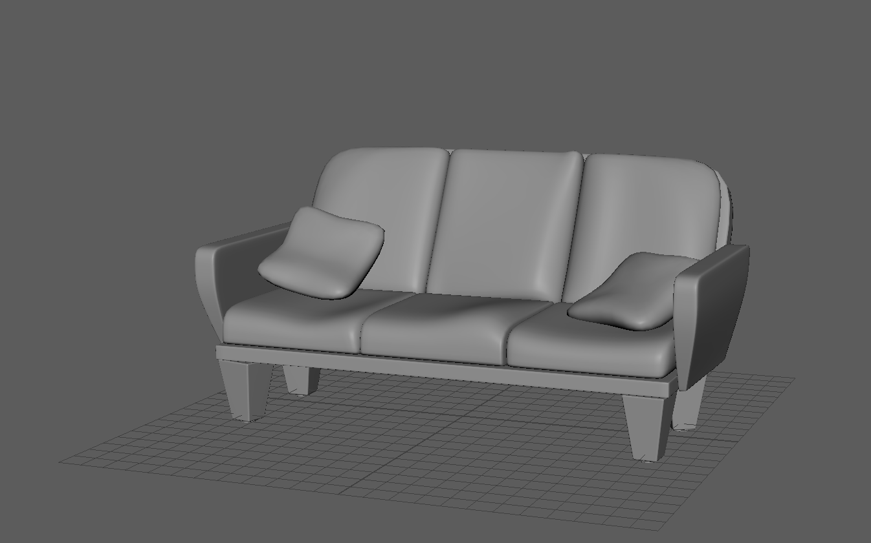

Created the base and back by using smooth mode and increasing density (with multicut) around edges. Created cushions by using smooth mode on cubes then edge loop to make the corners sharper before deforming it to make them look less perfect. Armrests were the same process as base and back but with mor edgeloops for control. Created Legs with beveled cubes and cylinders.

